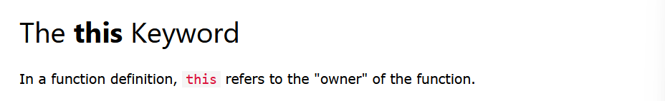

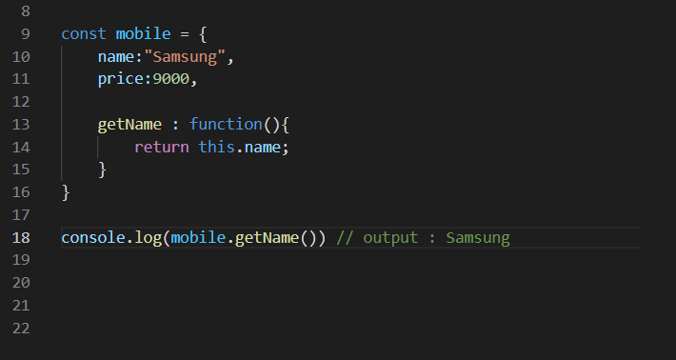

Here the owner of the function is the mobile object

Also think of it like

this means, this / yoo( mobile ) object

so in above we tell

return yoo object ( mobile object ) ko name key ko value